CO1 ASSESSMENT TOOL 2: CASE STUDY ANALYSIS

Intelligent Hospital Asset Tracking and Patient Flow Management Platform

Name: ABARAJITHAN S Reg.No: 192521299 Slot: D Course Code: CSA1007

1. Project Vision and Stakeholders
1.1 Project Vision
To develop an intelligent digital platform that enables hospitals to monitor medical assets, optimize patient flow, reduce waiting time, and improve healthcare delivery through IoT, Artificial Intelligence, RFID technology, and real-time analytics. The platform aims to enhance patient satisfaction, maximize hospital resource utilization, and support data-driven decision-making.
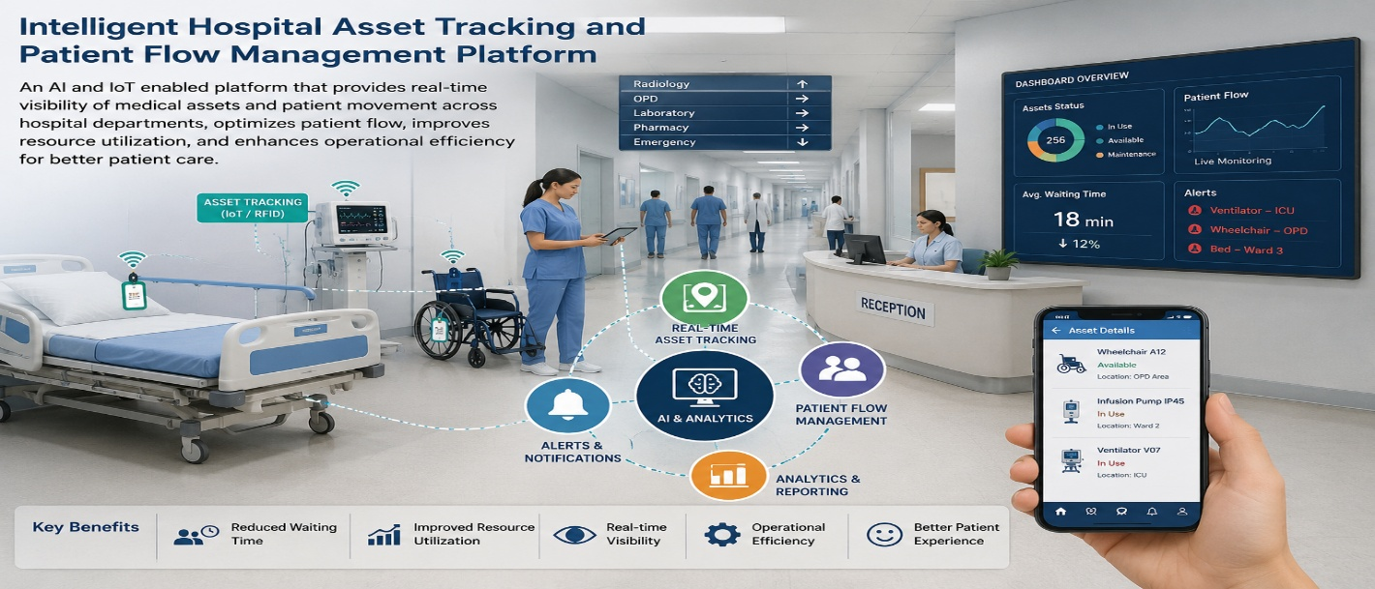
1.2 Project Objectives
- Provide real-time tracking of medical equipment using RFID and IoT.
- Monitor patient movement across hospital departments.
- Reduce patient waiting time through intelligent queue management.
- Predict equipment availability using AI analytics.
- Generate hospital performance reports and dashboards.
- Deliver emergency notifications and alerts instantly.
1.3 Key Stakeholders
Stakeholder | Role / Interest in the Project
Patients | Receive timely treatment with minimal waiting time.
Doctors | Access medical equipment quickly and monitor patient progress.
Nurses | Track patient locations and equipment availability efficiently.
Hospital Administrators | Monitor hospital operations and improve resource utilization.
Biomedical Engineers | Maintain medical equipment and monitor device health.
Reception Staff | Manage patient registration, appointments, and admissions.
System Administrator | Maintain databases, security, and system performance.
Government/Healthcare Authorities | Ensure compliance with healthcare regulations and standards.

2. Epics and User Stories
The project requirements are divided into seven major Epics. Representative user stories are written using the Agile format.
Epic 1 – Hospital Asset Tracking
User Story
As a hospital administrator, I want to track medical equipment in real time so that equipment can be located immediately whenever required.
Epic 2 – Patient Flow Management
As a patient, I want to receive queue updates and appointment notifications so that my waiting time is minimized.
Epic 3 – Equipment Availability Prediction
As a doctor, I want to know equipment availability before requesting it so that treatment is not delayed.
Epic 4 – Appointment & Queue Management
As a reception staff member, I want to schedule patient appointments automatically so that hospital workflows become more efficient.
Epic 5 – Analytics & Reporting
As a hospital administrator, I want performance dashboards and reports so that I can make informed management decisions.
Epic 6 – Emergency Notification System
As a nurse, I want emergency alerts delivered instantly so that critical patients receive immediate attention.
Epic 7 – Security & User Management
As a system administrator, I want secure authentication and role-based access so that patient and hospital data remain protected.
3. Acceptance Criteria
Acceptance criteria are defined using the Given–When–Then format.
- Medical equipment location is displayed in real time.
- Patient queue updates automatically after every consultation.
- AI predicts equipment availability accurately.
- Notifications are delivered instantly to doctors and nurses.
- Performance dashboards update automatically.
- Emergency alerts reach responsible staff immediately.

4. Product Backlog Prioritization
Rank | User Story | Priority | Justification
1 | US-01 Track Hospital Assets | High | Core functionality required for efficient equipment management.
2 | US-02 Patient Queue Management | High | Directly improves patient satisfaction and hospital efficiency.
3 | US-03 Equipment Availability Prediction | High | Prevents treatment delays by ensuring equipment readiness.
4 | US-04 Appointment Scheduling | High | Essential for organized patient flow management.
5 | US-05 Emergency Notification System | Medium-High | Improves emergency response and patient safety.

6. Story Point Estimation
User Story | Story Points | Justification
US-01 Track Hospital Assets | 8 | High complexity involving RFID, IoT devices, cloud integration, and dashboards.
US-02 Patient Queue Management | 5 | Moderate complexity with scheduling algorithms and live updates.
US-03 Equipment Availability Prediction | 8 | Requires AI-based prediction models and historical data analysis.
US-04 Appointment Scheduling | 5 | Moderate complexity involving calendar management and notifications.
US-05 Emergency Notification System | 3 | Simple workflow with alert generation and message delivery.
US-06 Hospital Analytics Dashboard | 8 | High complexity involving visualization, reports, and predictive analytics.
US-07 Role-Based Authentication | 5 | Requires secure login, encryption, and access control mechanisms.

7. Sprint Goal and Expected Deliverables
7.1 Sprint Goal
"By the end of Sprint 1, hospital staff can securely log in, track medical equipment in real time, monitor patient queues, schedule appointments, and receive emergency notifications, establishing the core Minimum Viable Product (MVP) for intelligent hospital management."
- Functional hospital login and authentication module.
- Real-time RFID-based medical asset tracking system.
- Patient appointment and queue management module.
- AI-based equipment availability prediction dashboard.
- Emergency notification and alert system.
- Hospital analytics dashboard with key performance indicators.
- Sprint review demonstration covering the complete patient admission-to-treatment workflow.
- Updated and prioritized product backlog for Sprint 2.
This version follows the same organization, headings, tables, and level of detail as the uploaded sample while adapting the content to your project topic.

